Integrating Engineering Design Process with Challenge-Based Learning

Speaker: Amy Jameson, Science Teacher, Gilbert A. Dater High School
Date: Thursday, June 13, 2019
Time: 2:45-4 PM
Venue: University of Cincinnati, Baldwin Hall, room 741

Prepared by:
Matthew Bagazinski, Detroit Cristo Rey High School, Detroit, Michigan
RET Participant for Project #3: “Bio-Inspired Optimization”

This session was conducted by Amy Jameson, Science Teacher at Gilbert A. Dater High School, on Thursday June 13, 2019, from 2:45-4 PM at the University of Cincinnati in Baldwin Hall, room 741.

Amy Jameson began with some background information. Amy has been teaching science for over thirty years, spending the last nine years at Gilbert A. Dater High School, where she currently teaches Advanced Academic Physics, Advanced Academic Chemistry, and College Credit Plus Anatomy and Physiology. She participated in the RET program in 2010, as well as the CEEMS program, and she explained how she incorporates the Engineering Design Process in her classroom.

The first topic discussed was getting students to think about the Essential Question and Guiding Questions. Amy introduced a process to have students generate questions individually then decide the best questions in a small group. Then, as a class, students would decide the most important question, the Essential Question. After this, students would again work individually, to small groups, to the entire class, to generate Guiding Questions, questions to gather information needed to solve the problem. Amy gave the RET participants the worksheet she would give students and guided them through this process. As a science teacher, she needs to make sure that her students recognize the difference between science and engineering. She emphasized that difference by comparing the Scientific Method with the Engineering Design Process, as seen in Figure 1.
Figure 1: Comparing Scientific Method
and EDP

Next, Amy introduced the Challenge-Based projects she uses in her classes, skillfully incorporating required content into the engineering design. In Chemistry, students must design cheaper alternatives to instant hot or cold packs. They will research on their own what types of reactions produce or take in heat and how to calculate the temperature change in water as a result. Students also run experiments to optimize the amounts and packing methods before producing a prototype to be tested. In Physics, students design an airplane wing inspired by nature. While not as directly tied to the content, Amy makes connections throughout the year to topics that are relevant for analysis, such as the effect of a torque on the overall structure or determining the center of mass for an oddly shaped object. The students conclude their project by testing their design at the Aerospace Engineering department at the University of Cincinnati. These both were incredible examples of Challenge-Based Learning, as the problems were open-ended enough to allow creativity in the solutions, and the products could be clearly tested and compared in their meeting of the criteria.
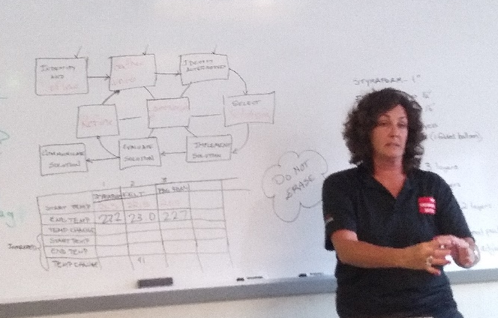
Finally, Amy reiterated how crucial the steps of the Engineering Design Process are for the students. Although it may be frustrating to spend a lot of effort on each step the first time through, the payoff is great, and it is amazing to see how well students perform on the second or third time through the EDP. Figure 2 shows Amy explaining how each part of the Engineering Design Process are implemented through the project. From the beginning, spending the time to define the Essential Question and Guiding Questions, students were committed to the project and had a clear idea of what they needed to do. The Challenge-Based aspect to the project also aided in student engagement. Often, the students who were not typically engaged in class enjoyed the hands-on design project.
Figure 2: Amy Jameson Reiterating the EDP

